4 – Git-HOL Hands-On

Step1: Checking if the master is clean
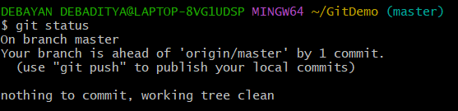

Step 2: Creating branch and committing changes
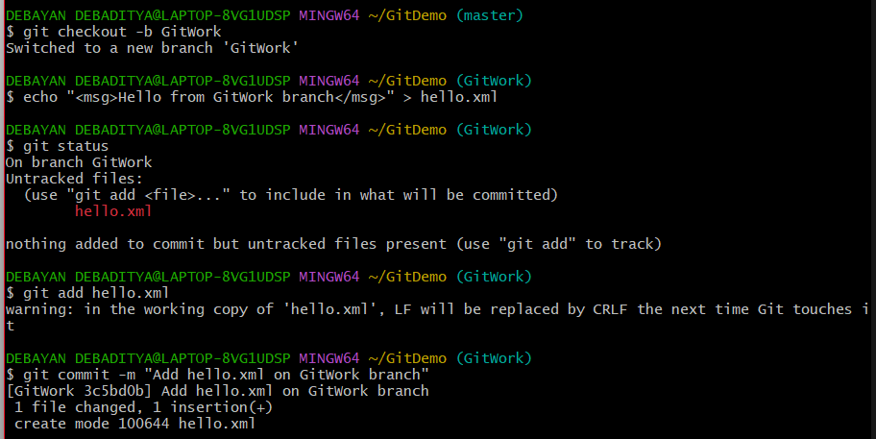

Step 3: Switching to master and creating a conflict
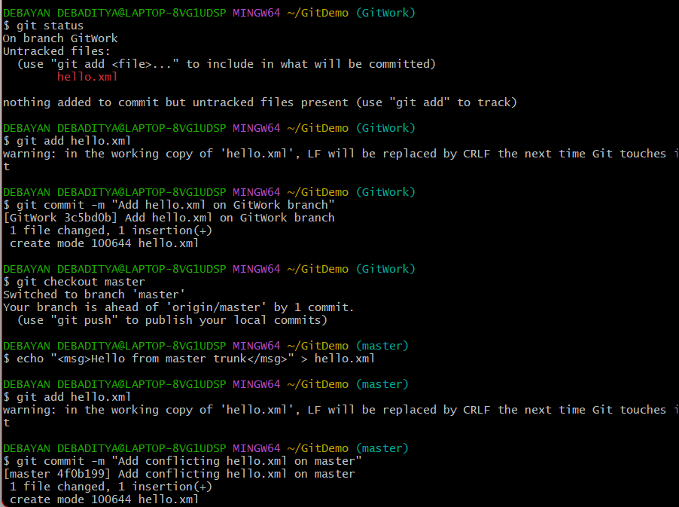
Step 4: History getting split
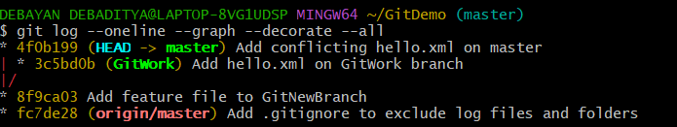
Step 5: Comparing the differences
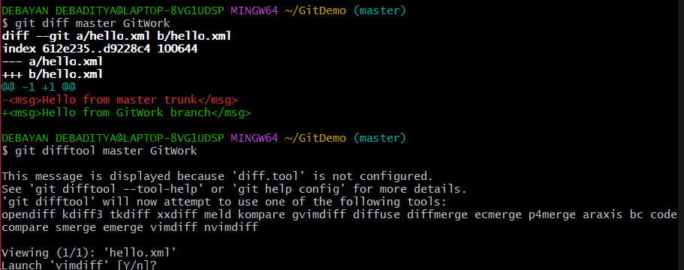
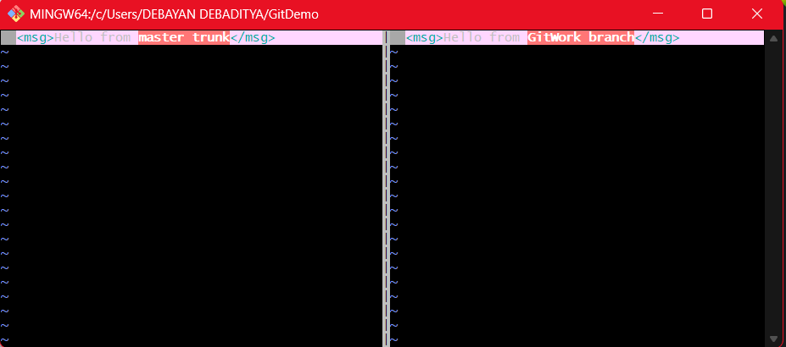
Step 6: Triggering the Merge Conflict
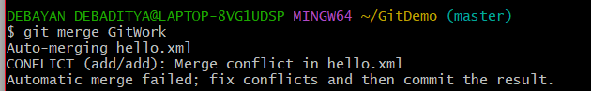
Step 7: Resolving the Conflict
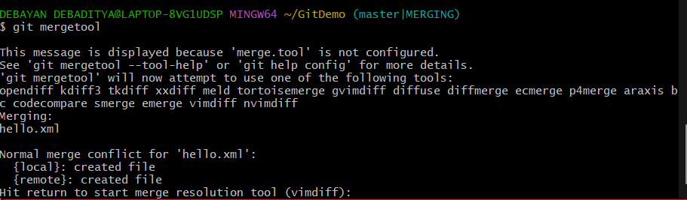
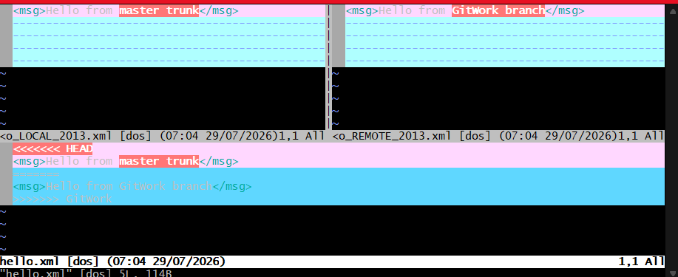

Step 8: Committing the Resolution
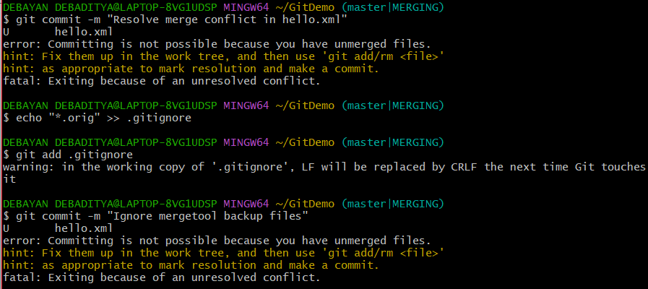
Step 9: Cleaning up and Verifying
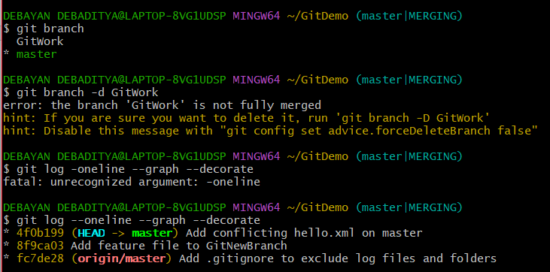
Step 10: Triggering the merge conflict by using the notepad++.exe manually
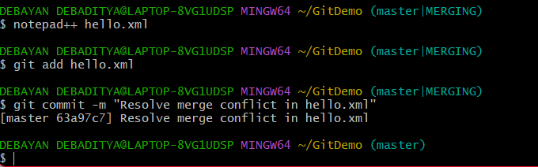

Step 11: Final Cleanup steps
